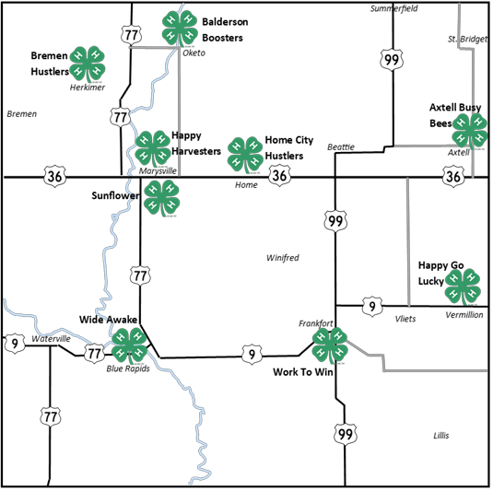

Leader Phone numbers are withheld on the website. They are available at the Extension Office or call 785-562-3531.

**Club Leaders:**

**Axtell Busy Bees**

* Julie Heiman

**Balderson Boosters**

* Colleen Voet

**Breman Hustlers**

* Linda Duever
* Matt Friedrichs

**Happy Go Lucky**

* Jennifer Matson
* Stephanie Rumbo

**Happy Harvesters**

* Tarcey Vering
* Cheri Dettke

**Home City Hustlers**

* Micki Nolte
* Sandra Schmitz

**Sunflower**

* Erin Wertenberger
* Jordy Ring

**Wide Awake**

* Leslie Pralle
* Nicole Porter
* Rachael Bishop

**Work To Win**

* Jessie Schneider
* Coila Farrell

**Marshall County 4-H Clubs**